Name:- Nitish Devendra Warbhe

Mail id:- [nitishdw@gmail.com](mailto:nitishdw@gmail.com)

**AWS Face Detection**

**AWS**

1. **AWS Login with username**

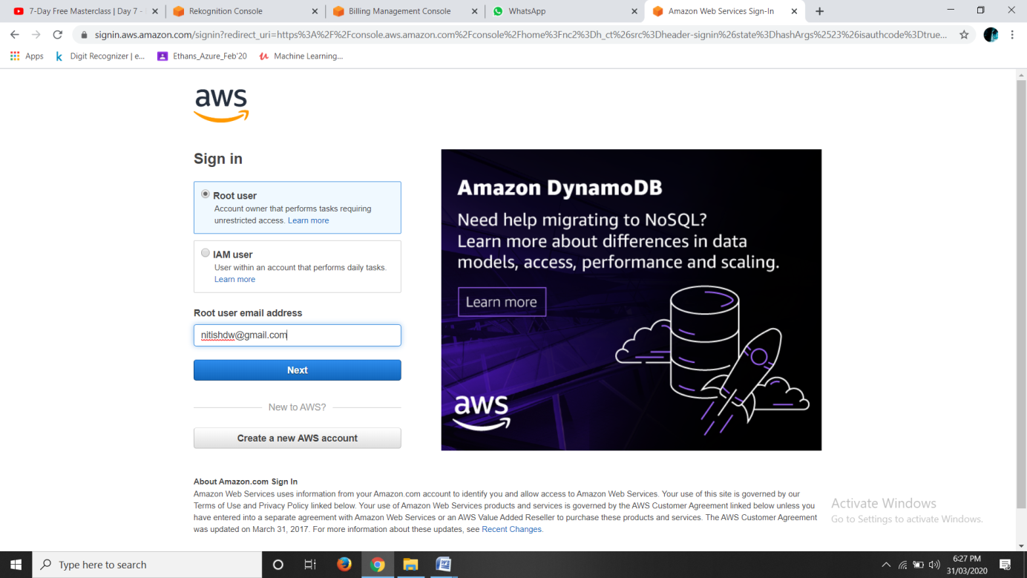

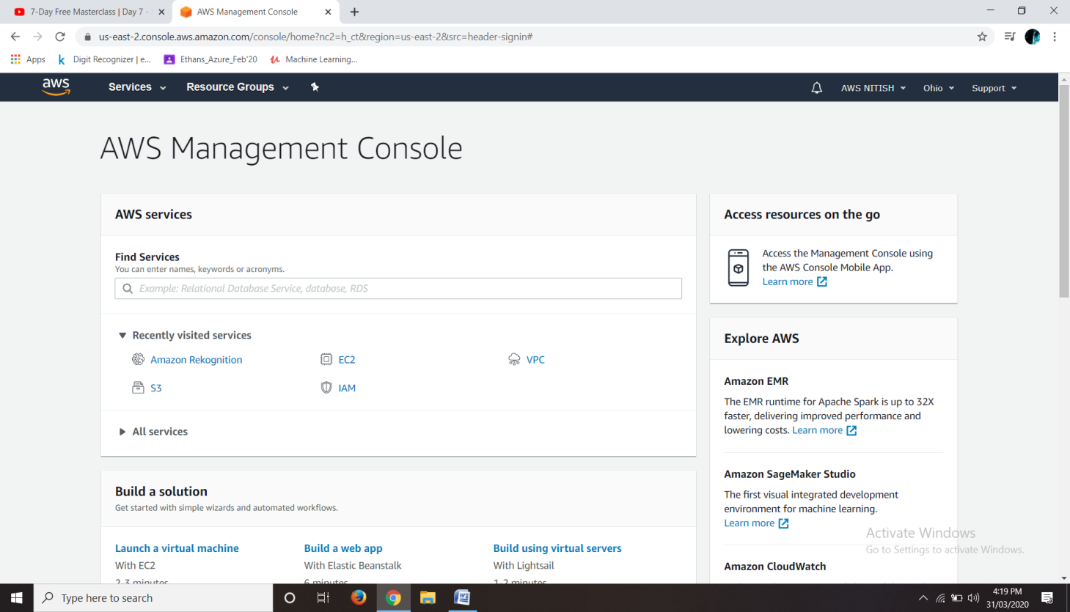

1. **EC2 Dashboard**

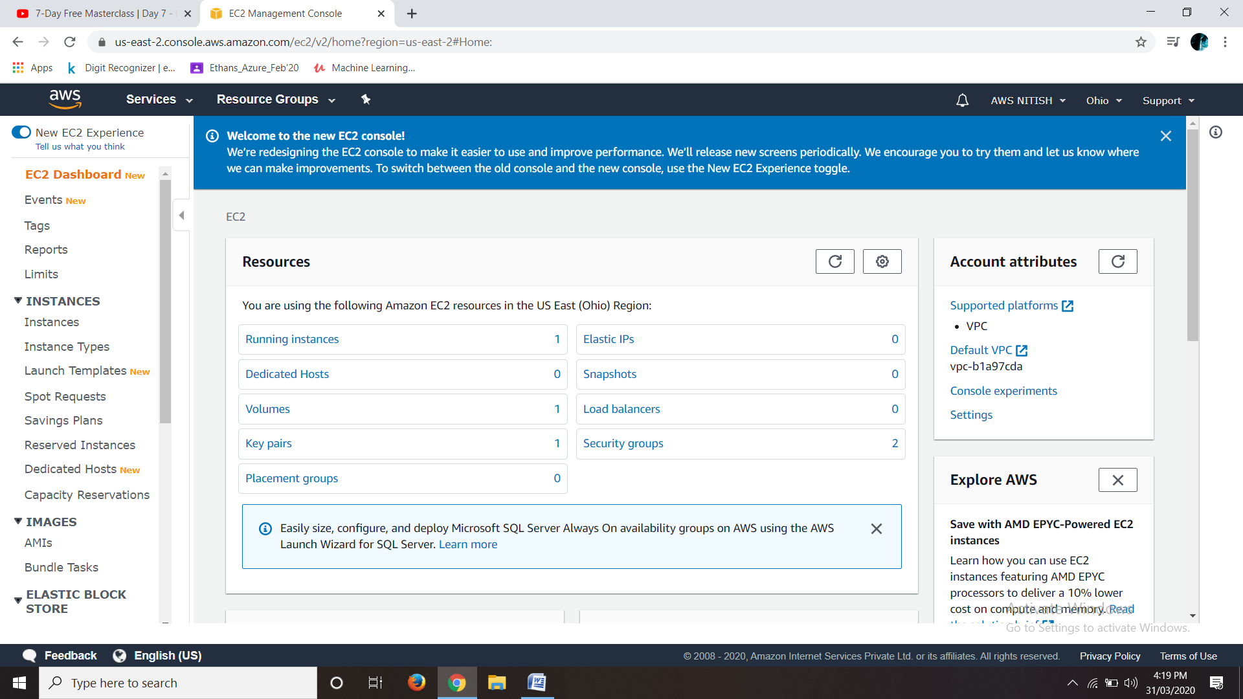

1. **S3 Dashboard**

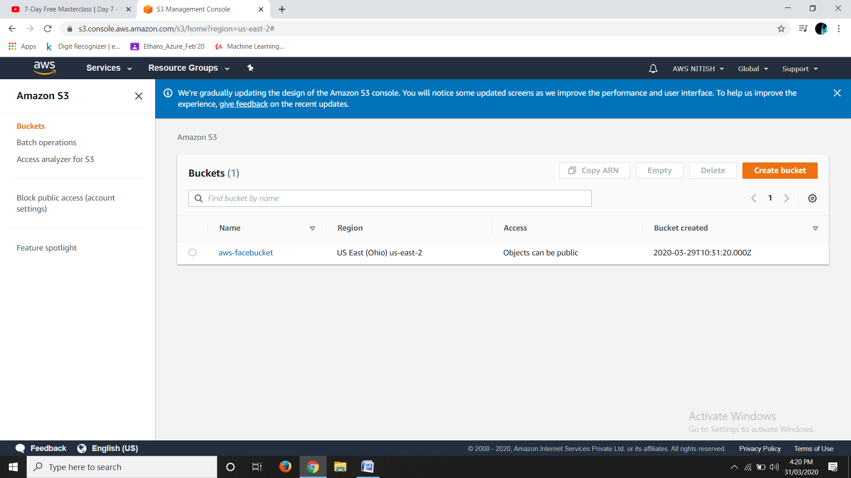

1. **Rekognition Dashboard**

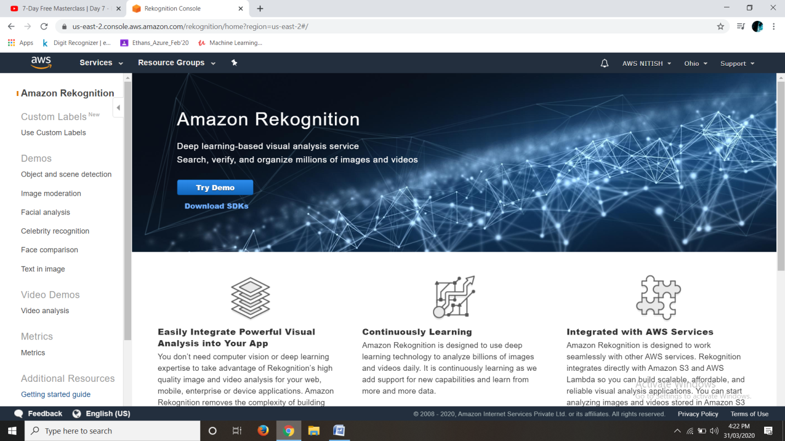

**EC2**

1. **Choosing an AMI**

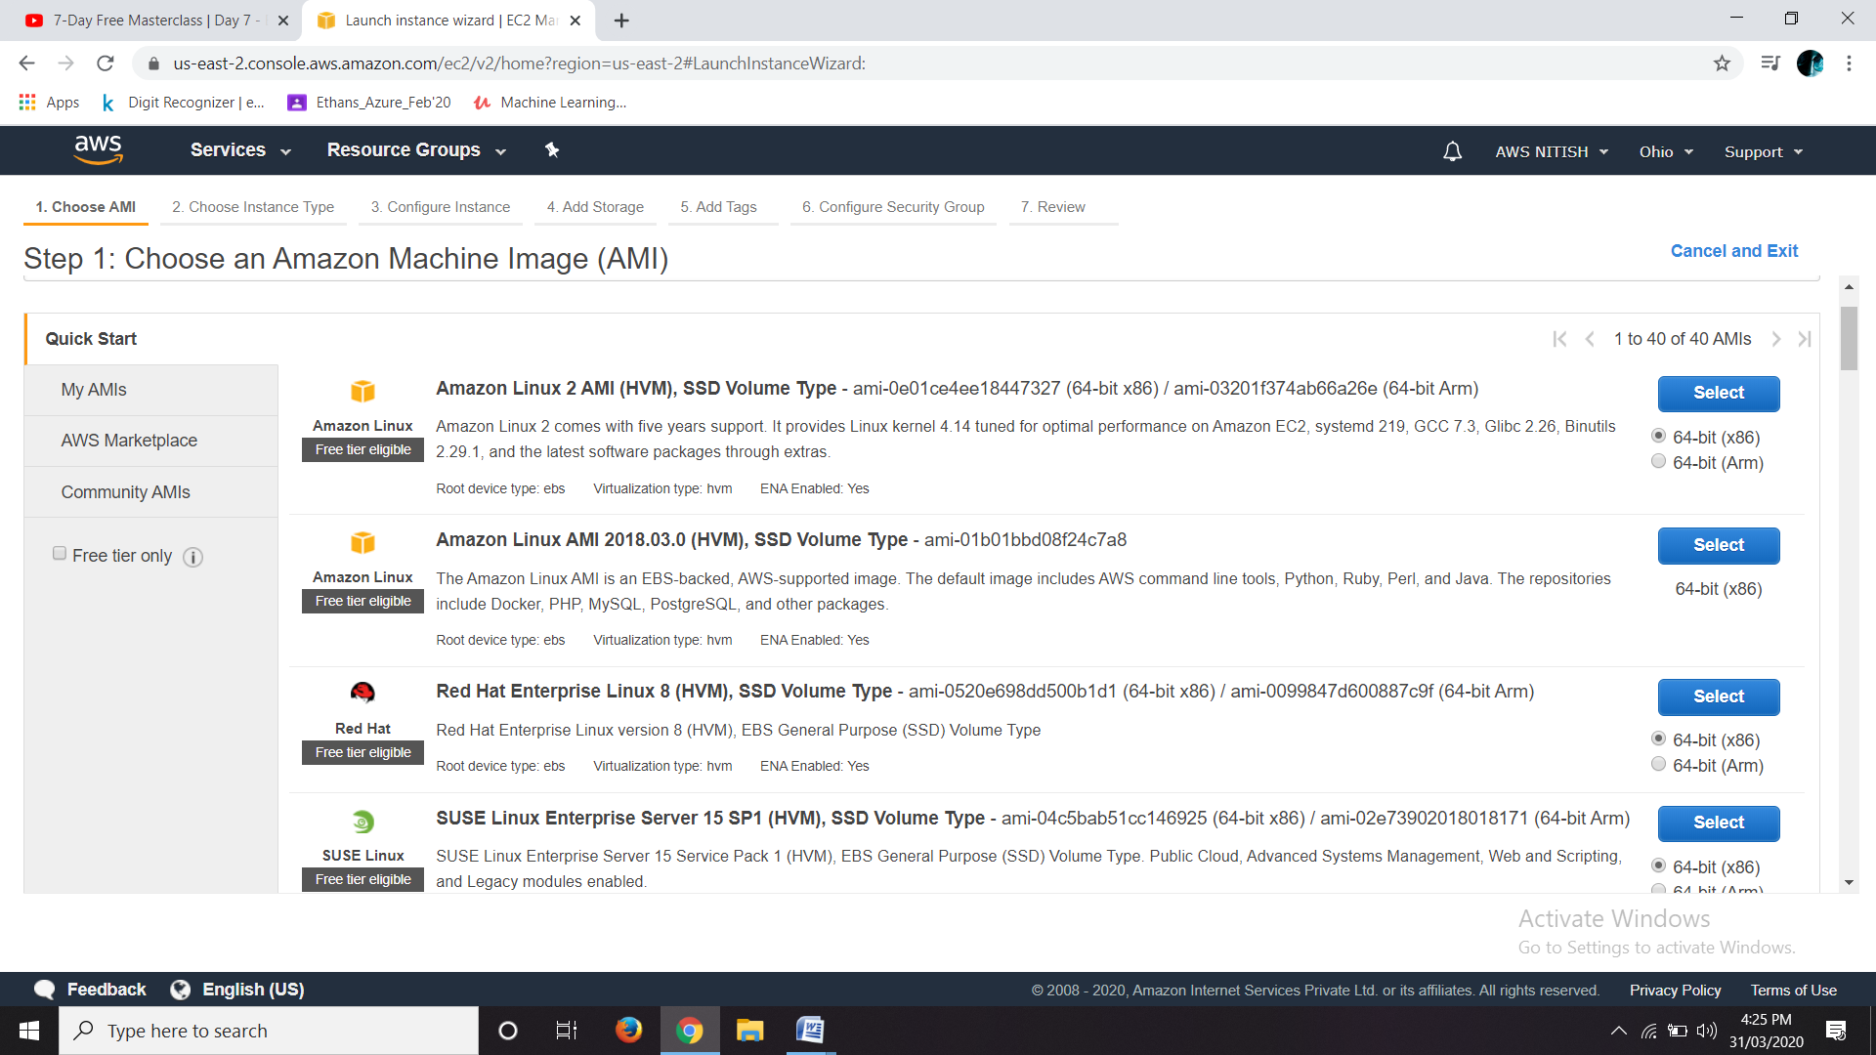

1. **Choosing an Instance type**

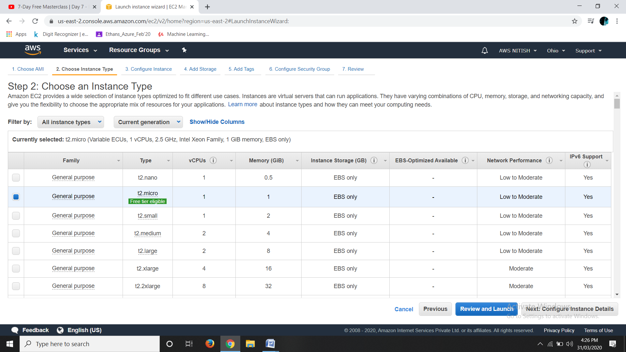

1. **Adding Storage**

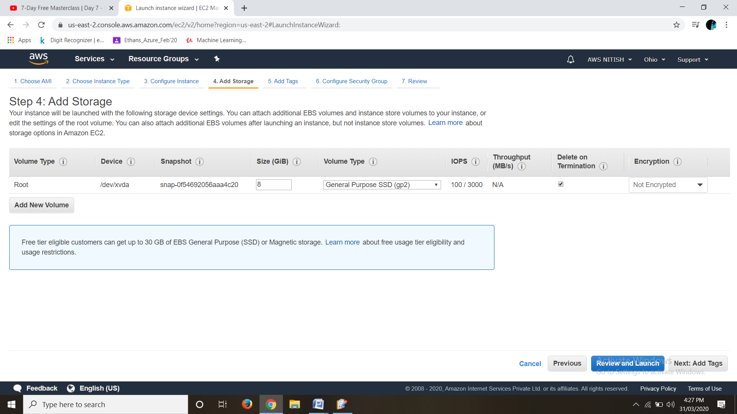

1. **Configuring the security group**

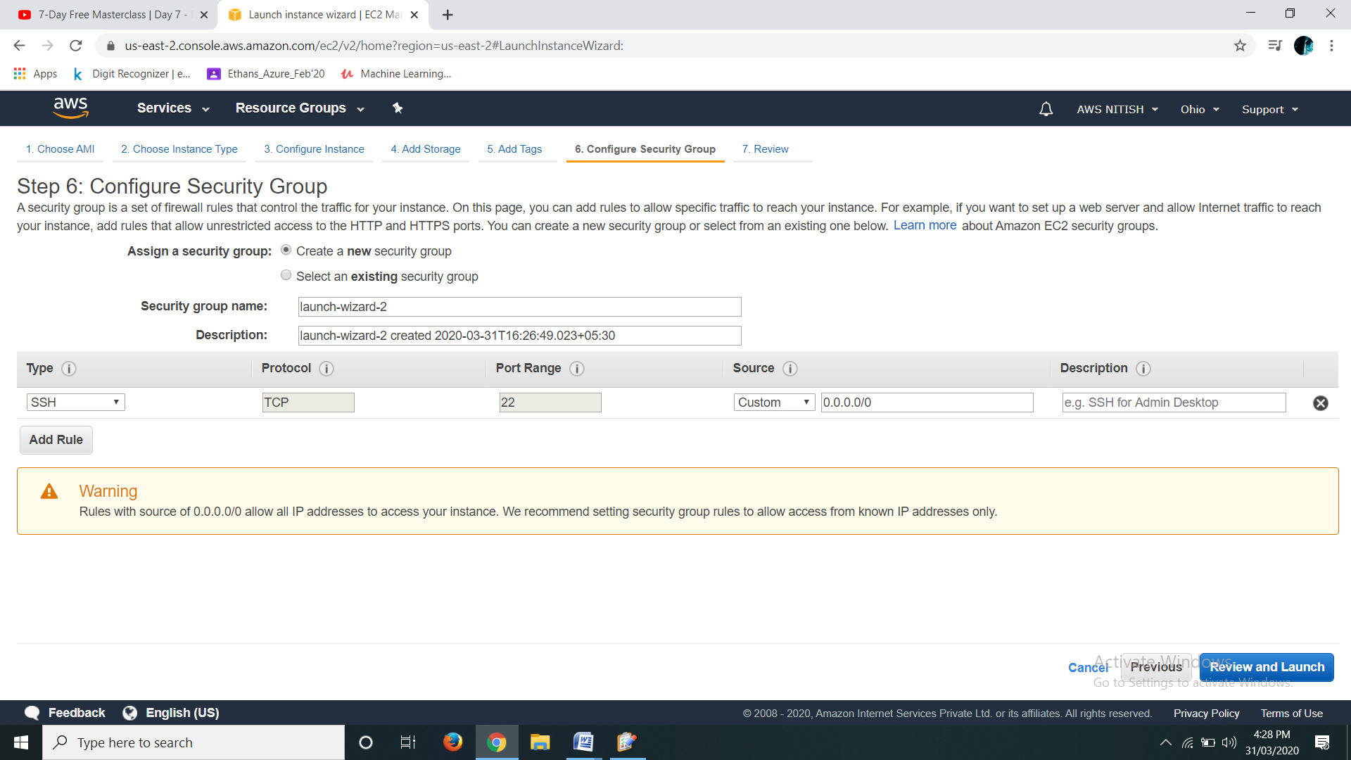

1. **Key pair Download**

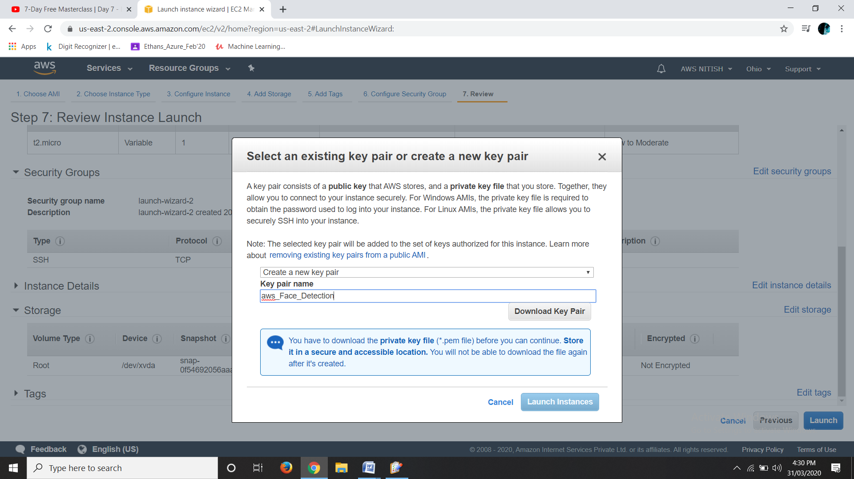

1. **PuTTYgen conversion from pem to ppk (Done on Linux)**

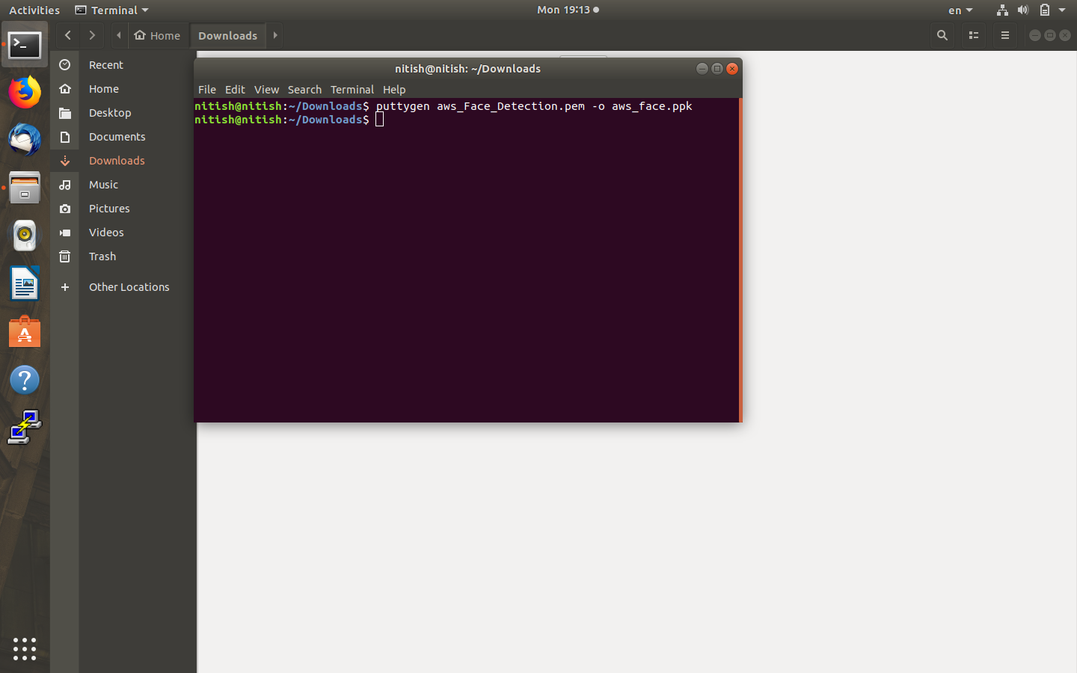

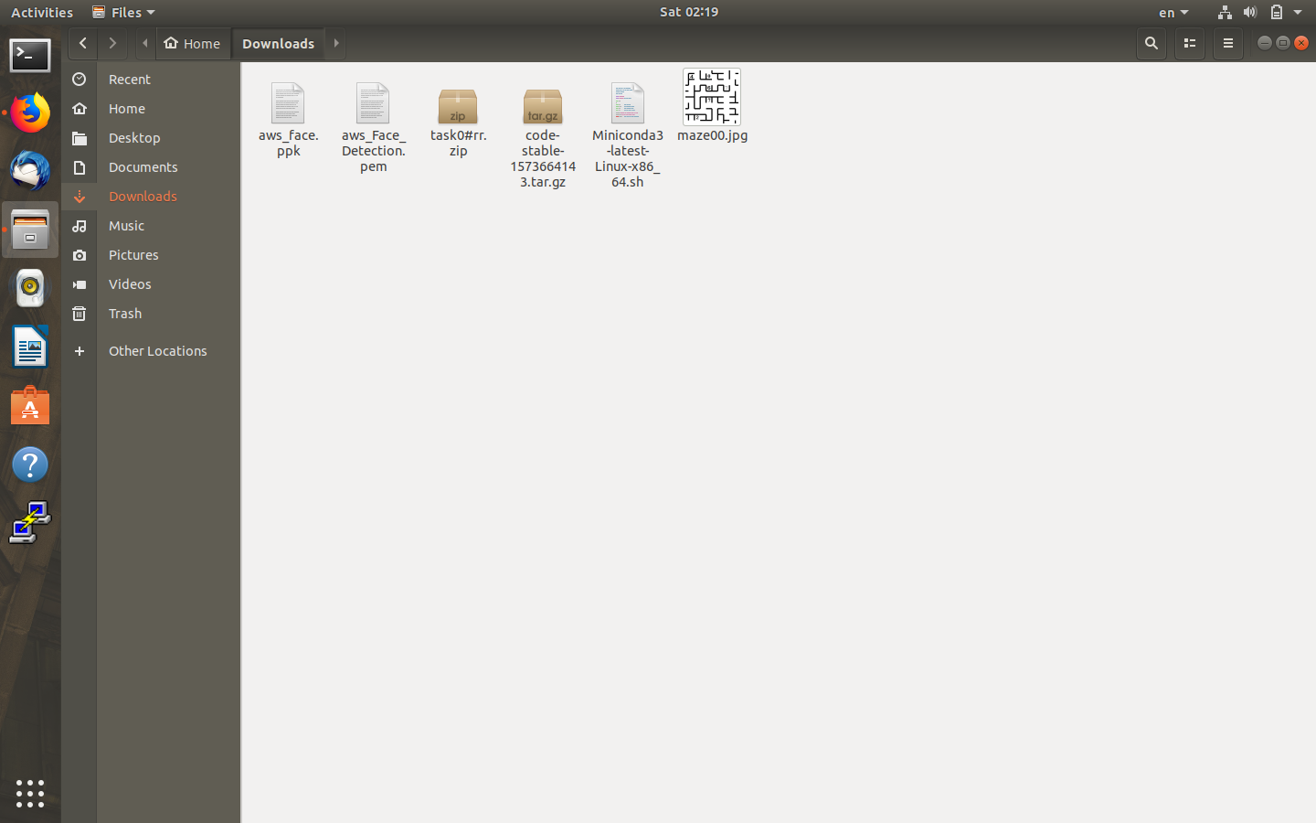

1. **Logged in EC2 black screen**

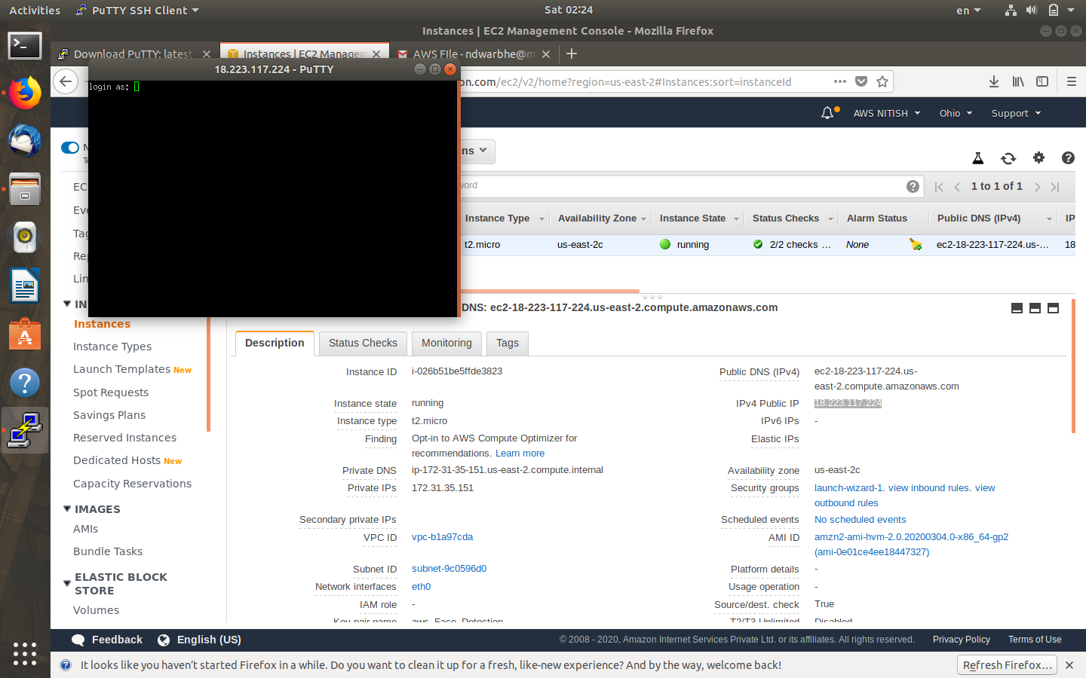

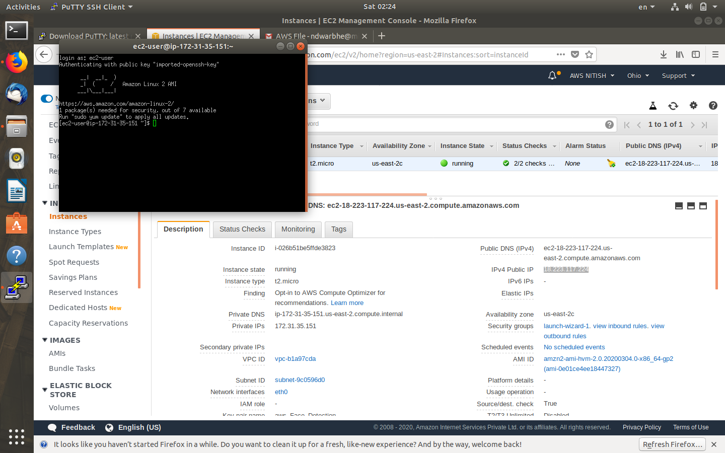

**S3**

1. **Created a bucket**

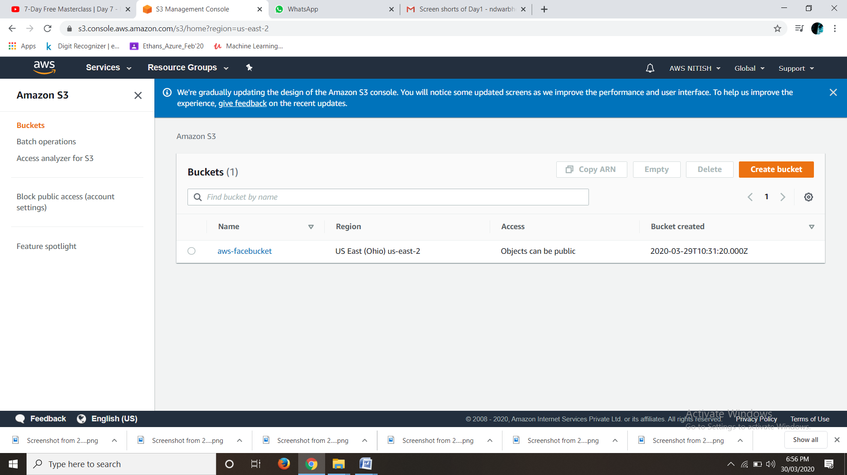

1. **Updated an object on bucket**

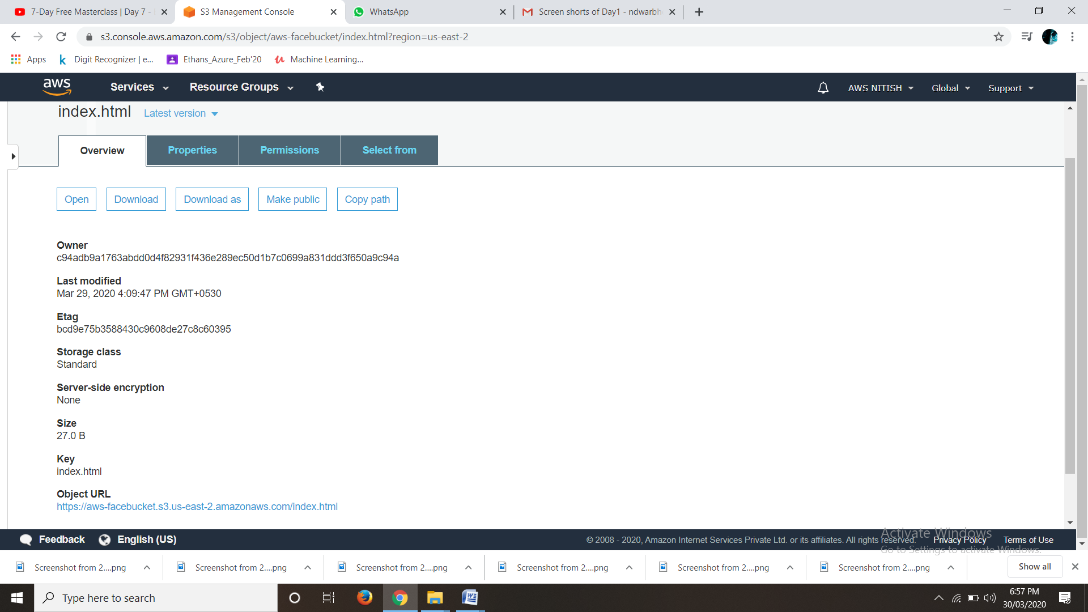

1. **Enabled Static Website**

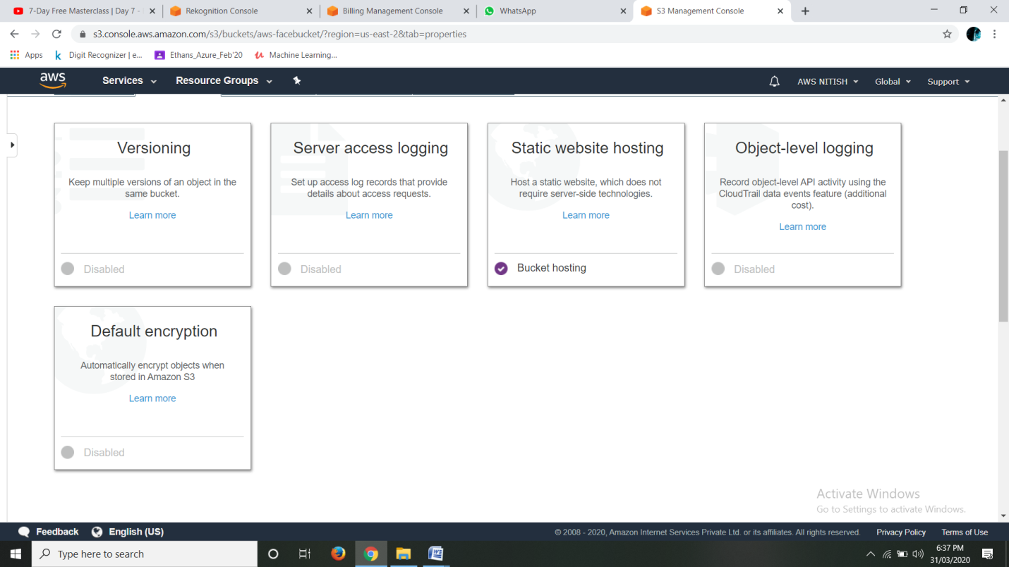

1. **Making the Object Public**

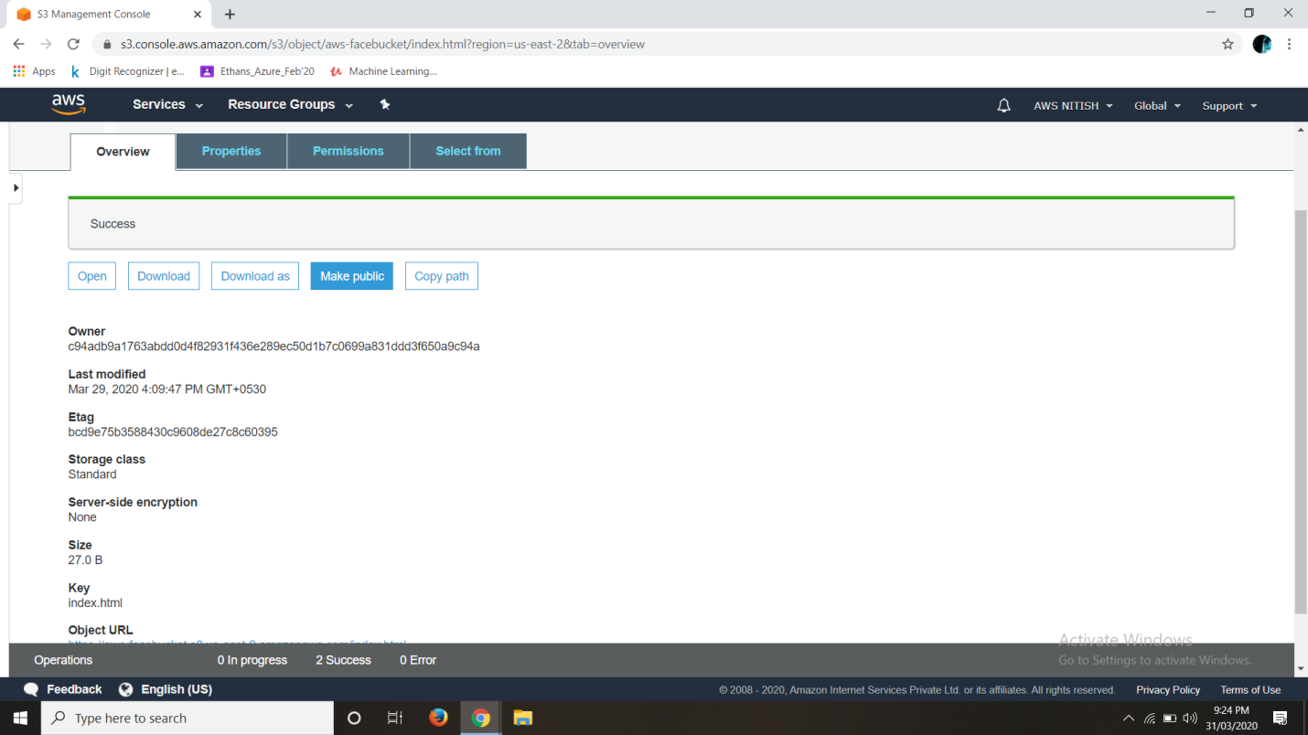

1. **Checking the S3 link on the browser**

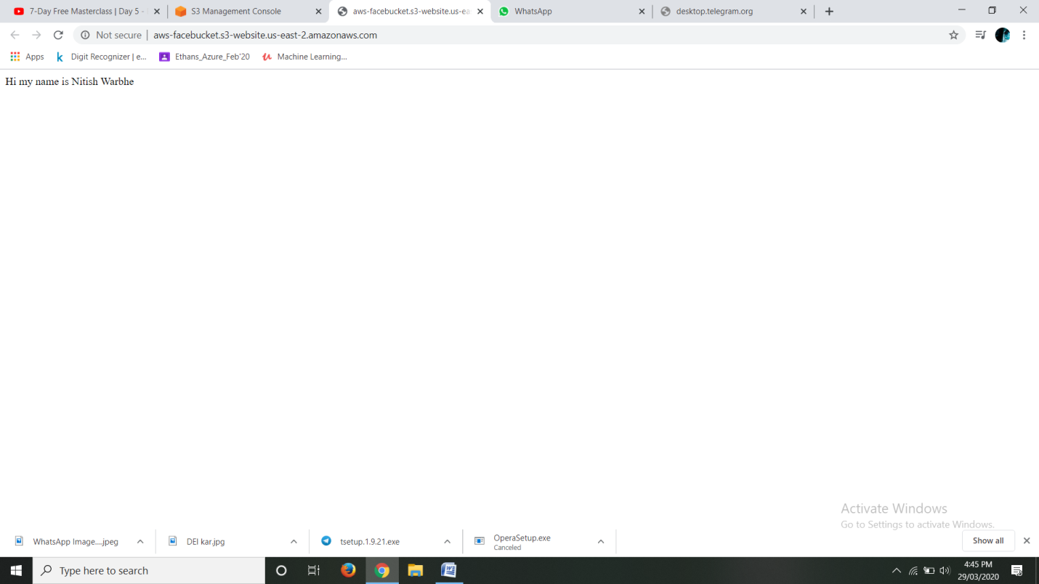

**Rekognition**

1. **Face Detect**

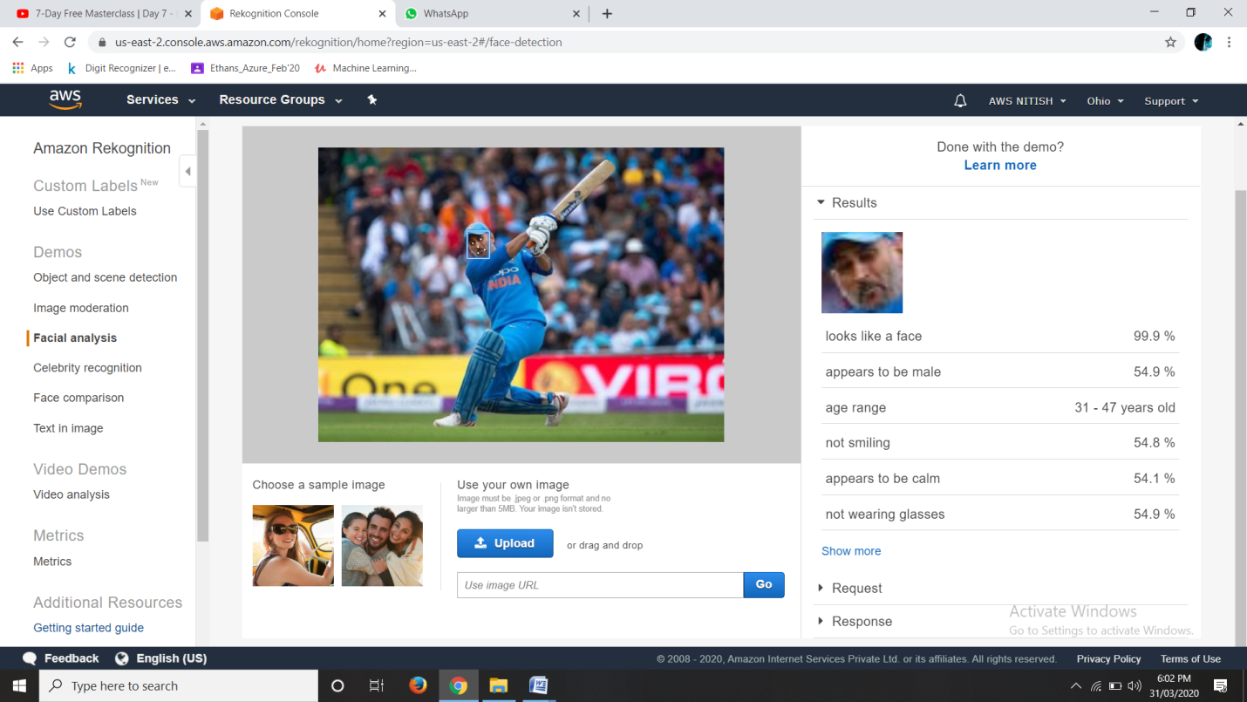

1. **Face Compare**

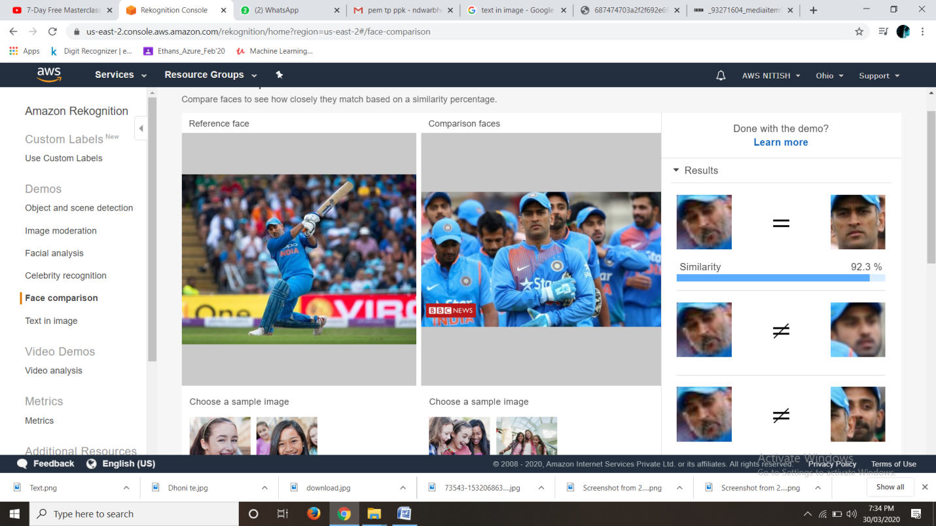

1. **Celebrity Recognition**

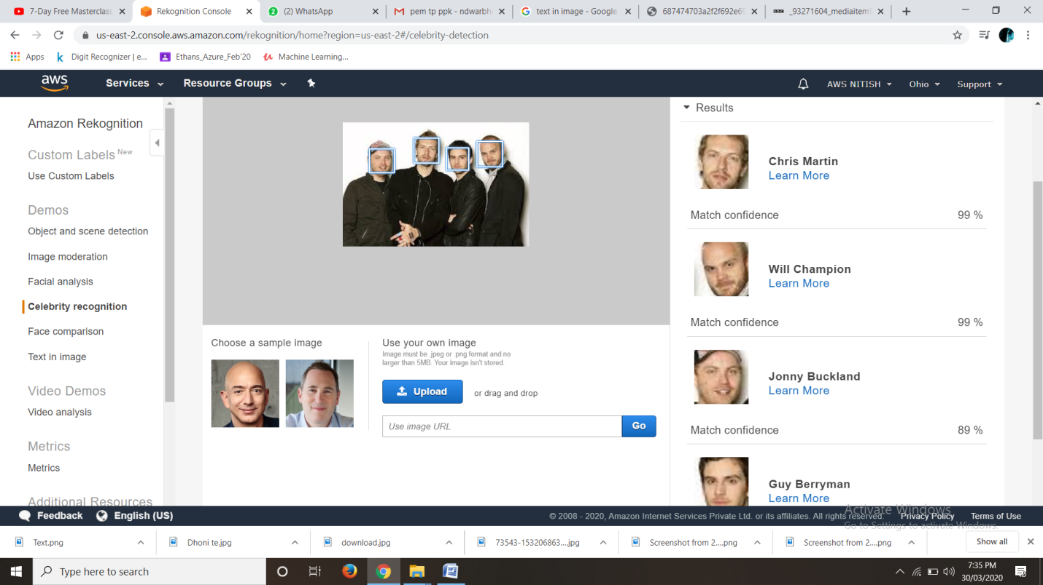

1. **Text Recognition**

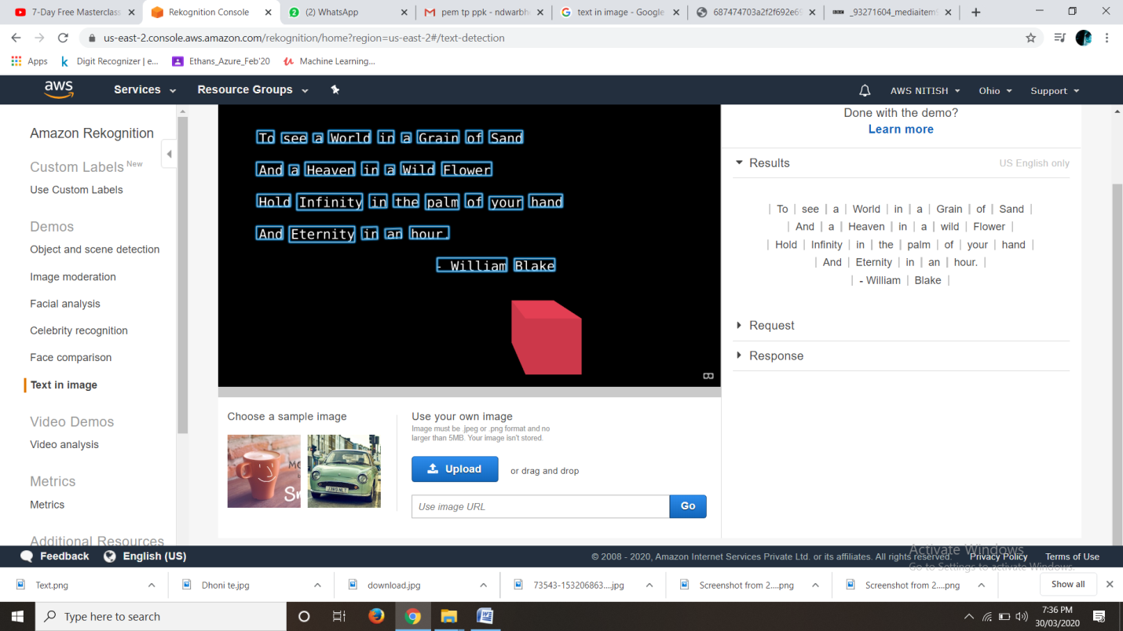

**EC2 & S3**

1. **Installing asw-sdk**

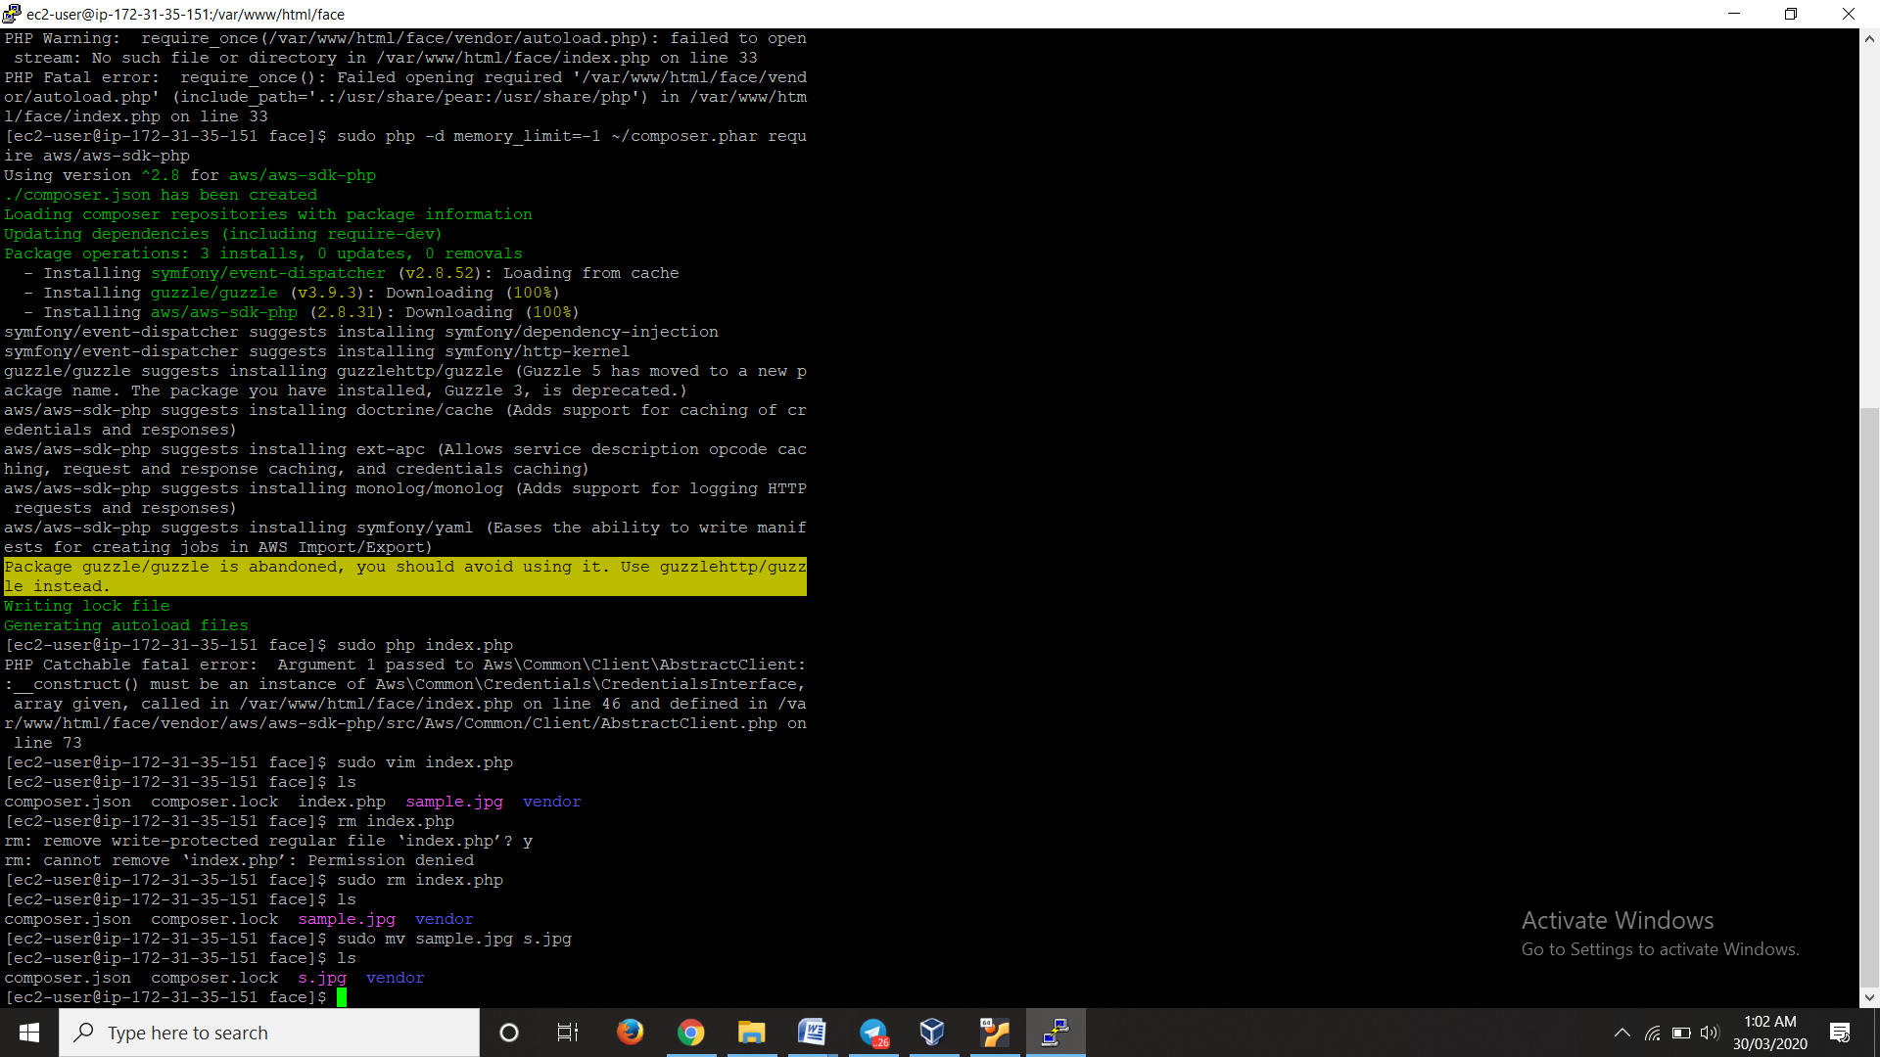

1. **Installing php**

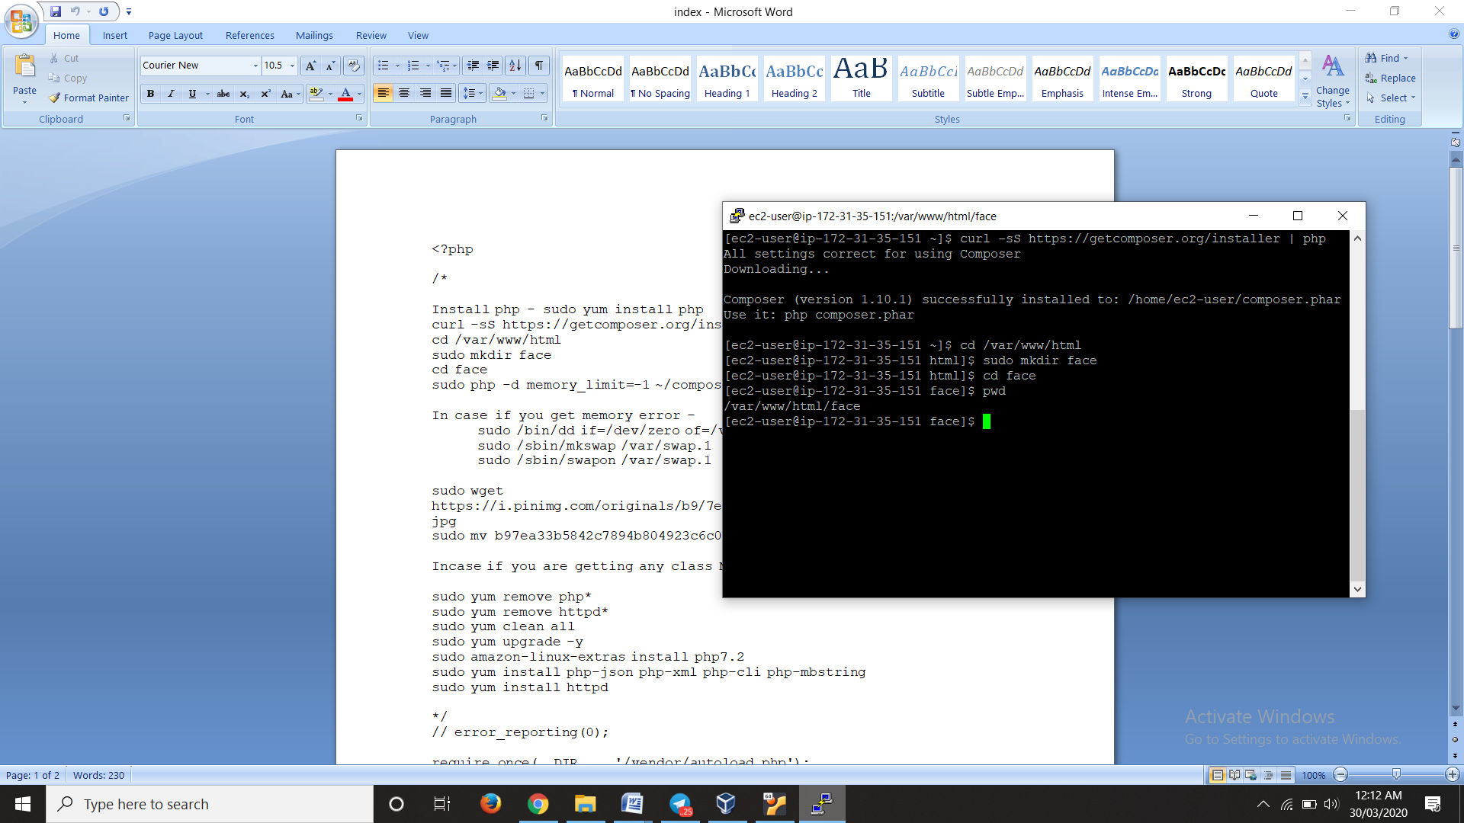

1. **Index.php file code**

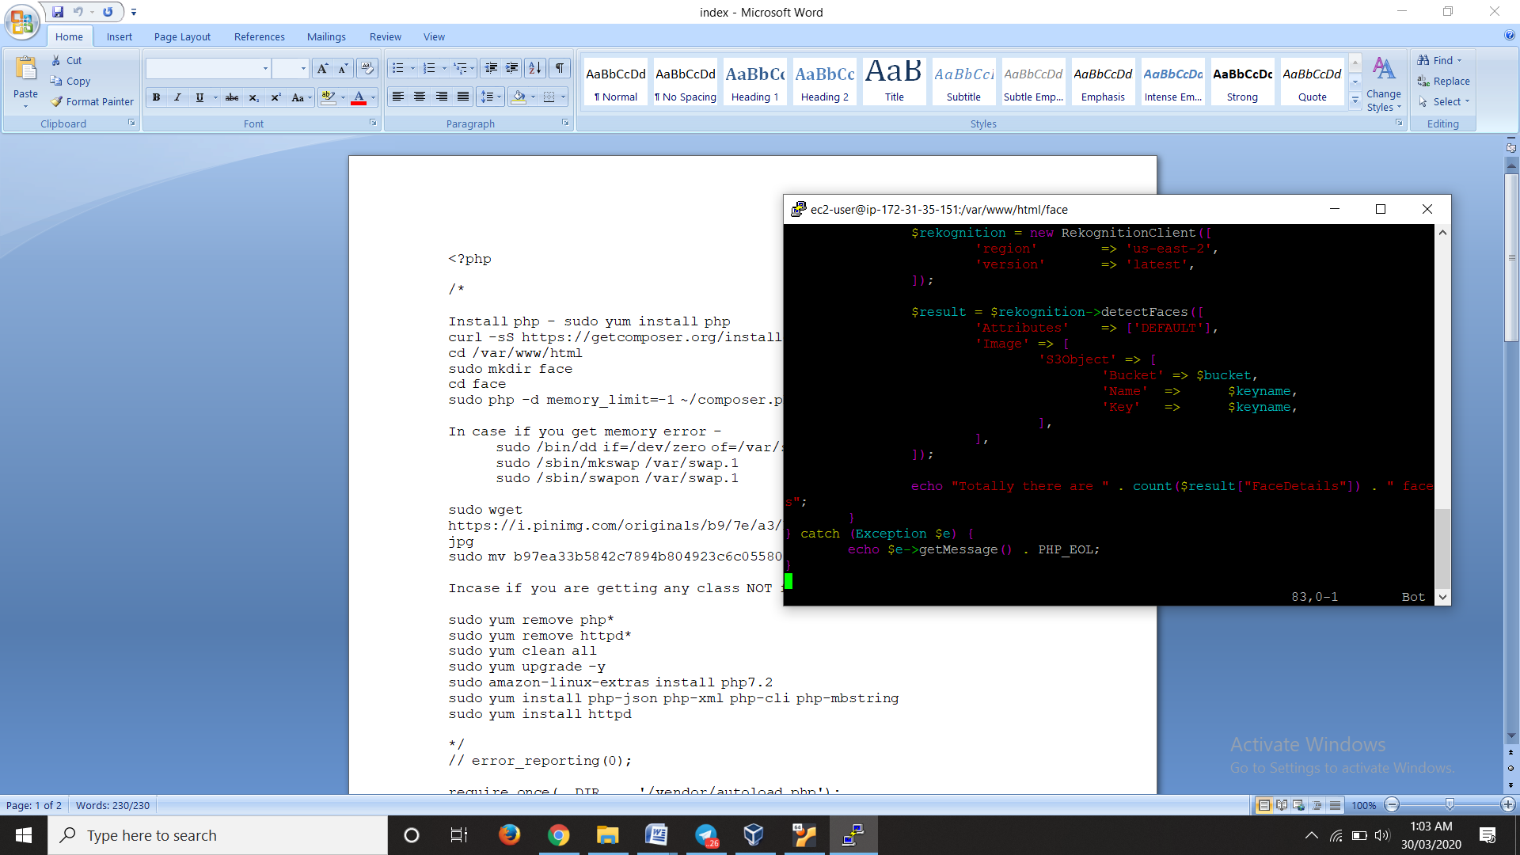

1. **Upload success screenshot**

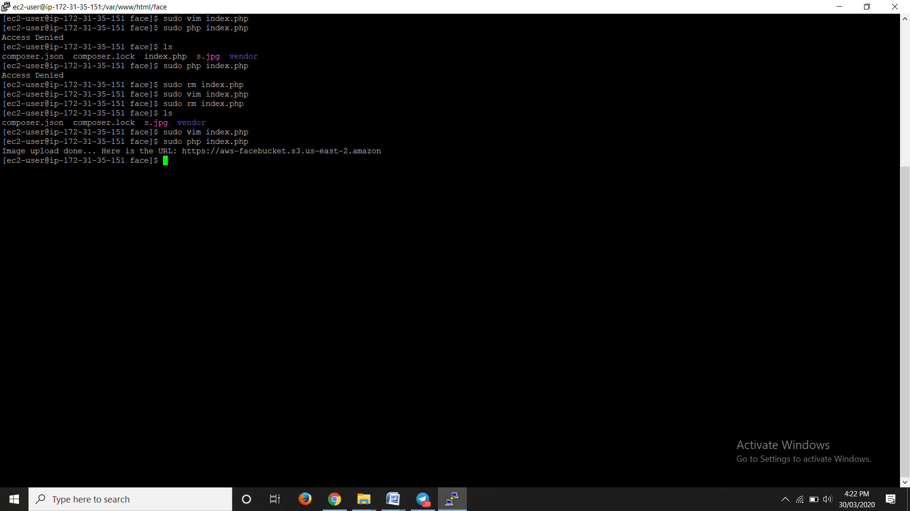

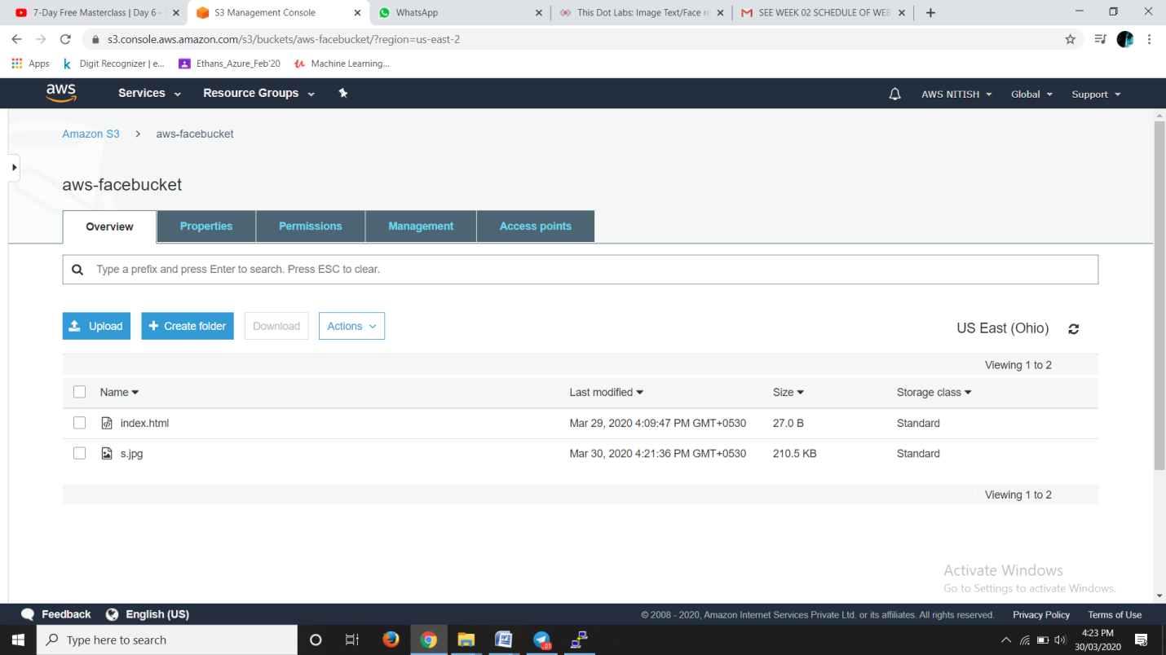

**EC2 & Rekognization**

1. **Face Detect success screenshot**

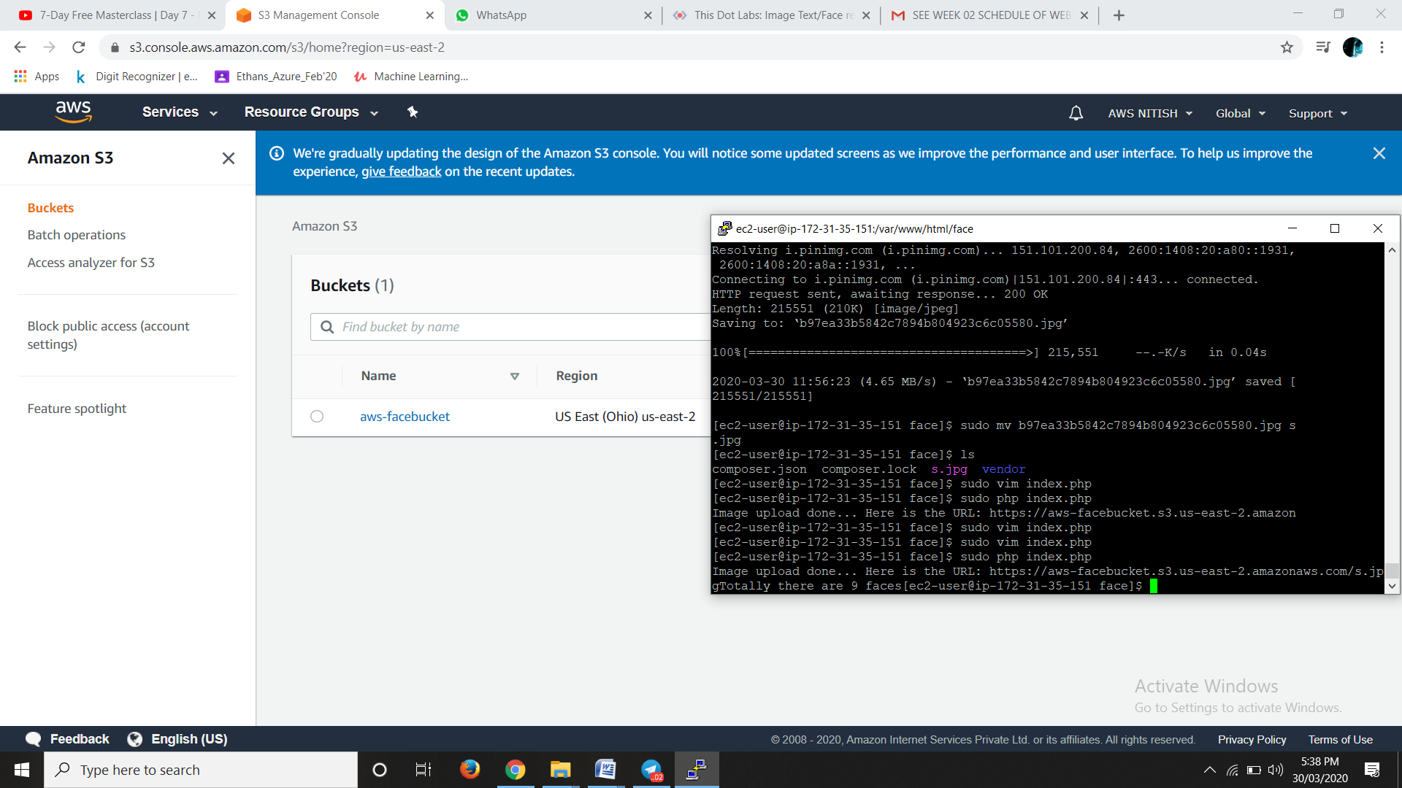

**Please note the name for certification:- Nitish D. Warbhe**